WHERE AM I NOW?
Dog sitting in Port Ludlow, WA Until May 2024!
The last time I updated this was March 2023, so I’ve got lots of news.
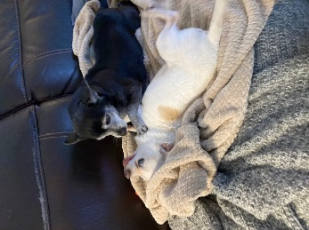
I continued to rent out my master bedroom to traveling nurses. In April I flew out to my daughter’s in So California to dog sit. Her younger daughter lives at home and was going to Germany and Amsterdam with a friend. While she was gone, my daughter and son-in-law went to Hawaii for their 25th anniversary. That left me with 5 dogs.
The oldest is Joey. A white Chihuahua that has no teeth left, can barely walk, but gives the others attitude. The next by age is Lily who gets fed up with Joey’s crap and in this photo was letting him know it.

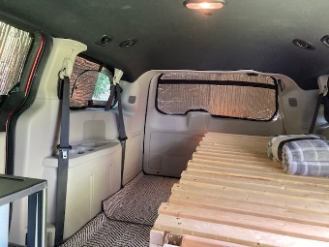
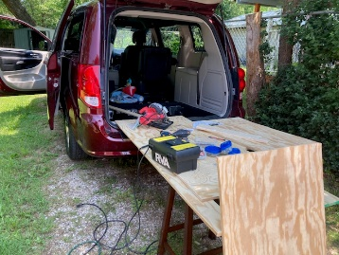
The day they came back, I flew to Seattle to visit their older daughter for a couple days then headed to my other daughter’s house in northern Idaho. My favorite granddaughter dog, Koda, is there. I didn’t get home to Springfield until May 8th. I abruptly traded cars and got a mini van and started turning it into a camper.

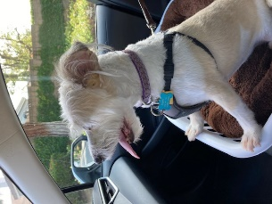
On June 28th I flew out to Orange County in CA to dog sit for a prior client in Yorba Linda. I took care of Poppy until July 10, went to my daughters for a few days then back to Yorba Linda with Poppy, flying home July 25th.
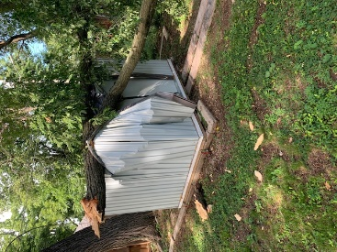
That storage shed my friend and I built last November was crushed by a tree limb on July 13th. It was hauled away and I bought a very nice shed from my neighbor who was moving.

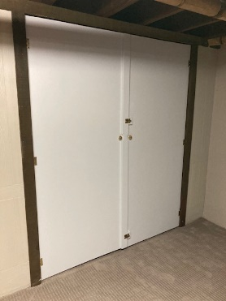
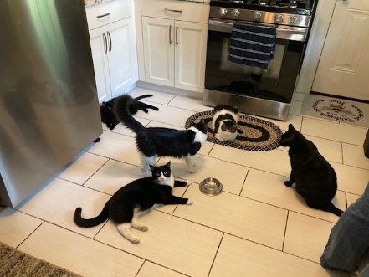
July 27th, I drove to Springfield, IL to cat sit for close friends. 5 cats! I also built those doors for a basement storage area and refinished a couple of old medicine cabinets in their new house.

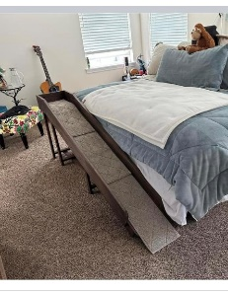
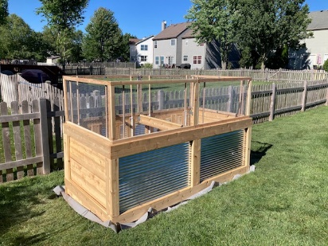
Next, I drove up to my God son’s house in Crystal Lake, IL to build a large planter box and dog ramp for their tiny Chihuahua to get up and down from their bed without help.
He’s a rocker in Chicago so of course I went to a show while I was there. I drove home July 12th.

July 16th I flew to San Diego to visit my youngest granddaughter and to cat sit while she went up to Idaho to visit her mom. She was packing up items at home in preparation for moving to Portland, ME. I flew home July 22nd. My daughter flew down to San Diego and they struck out cross country for Maine on July 29th.

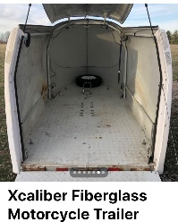
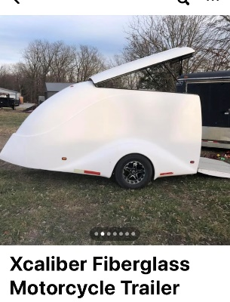
I decided it was time to sell my house and it went on the market in September. It showed 5 times in 3 days and I had 2 offers. I also found an old fiberglass motorcycle trailer I could turn into a better RV than just sleeping in my van. Only 12 feet long inside but super light and aerodynamic. Besides, I needed the van to carry all my tools.

And thus began its transformation that is still going on in January.

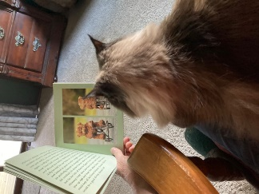
My house was due to close Oct 11, so I got rid of furniture, put stuff in storage and became homeless. My first stop was to cat sit for my friend Cindy just north of town.
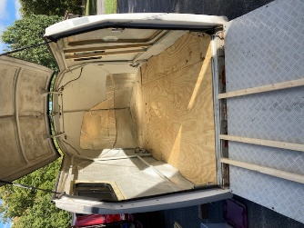
Her huge back driveway gave me an ideal workplace to get the trailer insulated and a plywood floor put in. I anchored down the dresser I had built for my house as it would provide the largest storage space for kitchen items, clothing, etc.

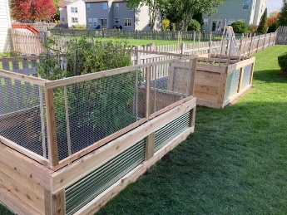
On Oct 19th I drove back to my God sons to build a second planter box for his wife, Kat. This one went up faster than the first and taught me something new: don’t slide ¾” dowel into ¾” PVC and expect to get it out when it expands from the weather. The removable screens around the top of the first planter were no longer removable. The second one got 5/8” dowel inside ¾” PVC. Repairs to the other one would have to wait. I had to get to Idaho to dog sit so they could fly to Chicago for work and to visit these guys.

I got as far as Sheridan, WY and the weather was closing in on the mountain pass NW of there. I found a United flight that left in a couple hours, called the airport manager’s office to confirm parking the van and trailer in their free airport lot was okay, and flew to Spokane. I didn’t fly back to Sheridan until Nov 5th and continued my drive.
I stopped for the night in Bozeman, MT and friends Sylvia and Wayne drove up from Big Sky to meet for dinner.
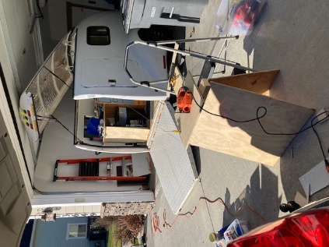
Once in Idaho, I drove the trailer straight to a welding shop to install a spare tire rack and battery rack near the nose. Then it went into my daughter’s garage where I continued working on it AFTER a trip to Maine!
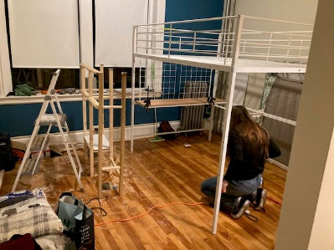
I left for Portland Nov 11th but arrived Nov 12th. My granddaughter was changing from a shared apartment to her own studio, so I stayed in the studio. This kid got a $2/hour raise in her first 30 day review at her new job!
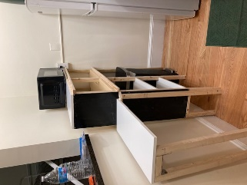
While there she put together the loft bed I ordered and I built her a free standing shelf with a few tools I bought her. I only stayed 4 nights but loved it!

I flew back to Chicago Nov 16th and hung out with Kat while my God son drove out west. I helped when I got there by driving to retrieve her little dog from the emergency vet’s office an hour away. And yes. The dog is fine.
We repaired the first planter box and she has since had both filled with dirt so they’re ready for the spring. I got back to Idaho for Thanksgiving.
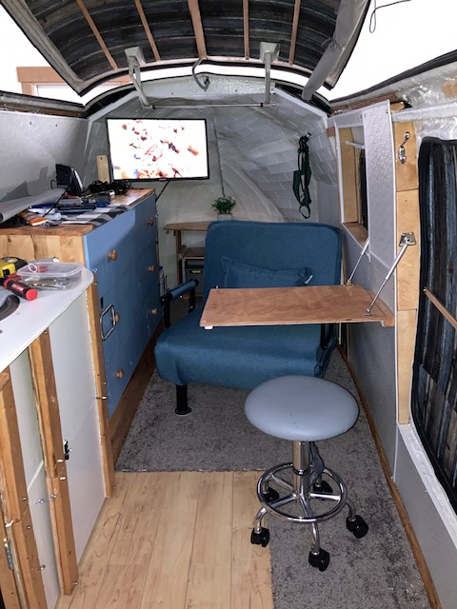
I spent the month at my daughter’s and put carpet in the trailer, built shelves, installed a TV and fold down table, ceiling and door panels, and have tent fabric for when the pop top is open. The chair folds down to a bed. There’s a sink with removable drain bottle, a power cord for campground hook ups, battery operated lights and AC lights, camp stove and single electric burner, toaster, crock pot, mini refrigerator, inverter, etc. In the spring I’ll add soler panels to the roof.
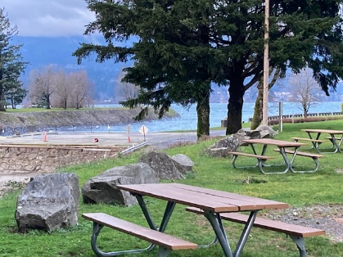
Christmas day I left for the Seattle area but again had to dodge bad weather. I went the long way around through Portland, OR, stopping for the night in Connell, WA and Cascade Locks, OR.

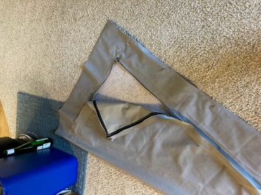
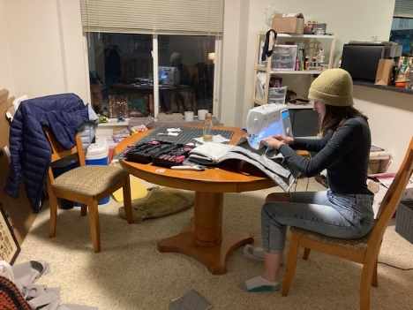
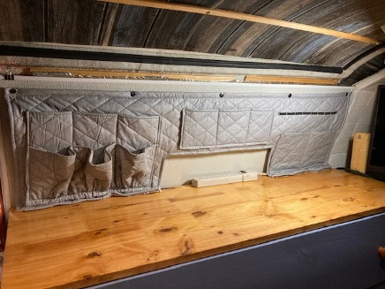
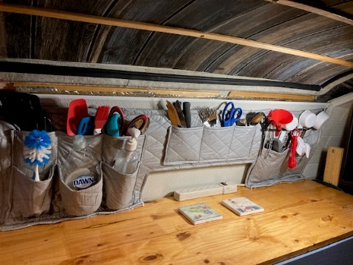
I spent 8 nights at an RV park in south Everett, WA and went to my granddaughter’s during the day for her help sewing a few things for the trailer. She made the curtains, sewed an organizer I designed, and she sewed mosquito netting into the tent panels for the pop up.

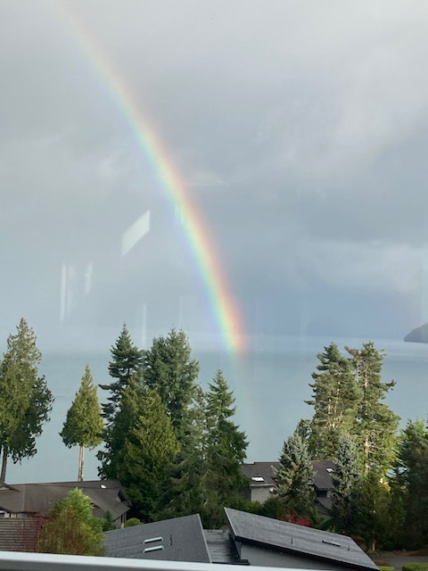
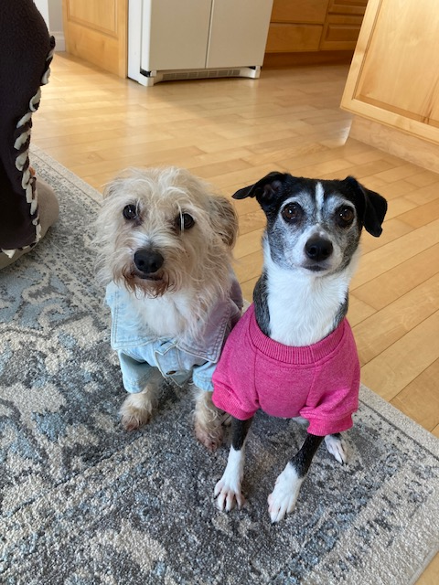
I had to be in Port Ludlow Jan 4th to start a dog sit that will take me to mid-May for prior clients from 2016. You can’t beat this view and the dogs, Zipper and Abby, are very sweet.

That’s it!
Now I’ll update my numbers on the first page to reflect all this.
BYE!

